Queen’s University

City of Kingston Student Housing Platform

Sean Liang, Elaine Wu, Gavin Cheng, Kyle Ding

CISC 499: Advanced Undergraduate Project

Professor Wendy Powley

8 April 2024

**Frontend**

**Homepage**

We used HTML5, CSS3, and JavaScript to create the frontend of our application.

The homepage serves as the entry point for users. It comprises of three main components: the *left sidebar*, the *top navigation bar*, and the *interactive map*.

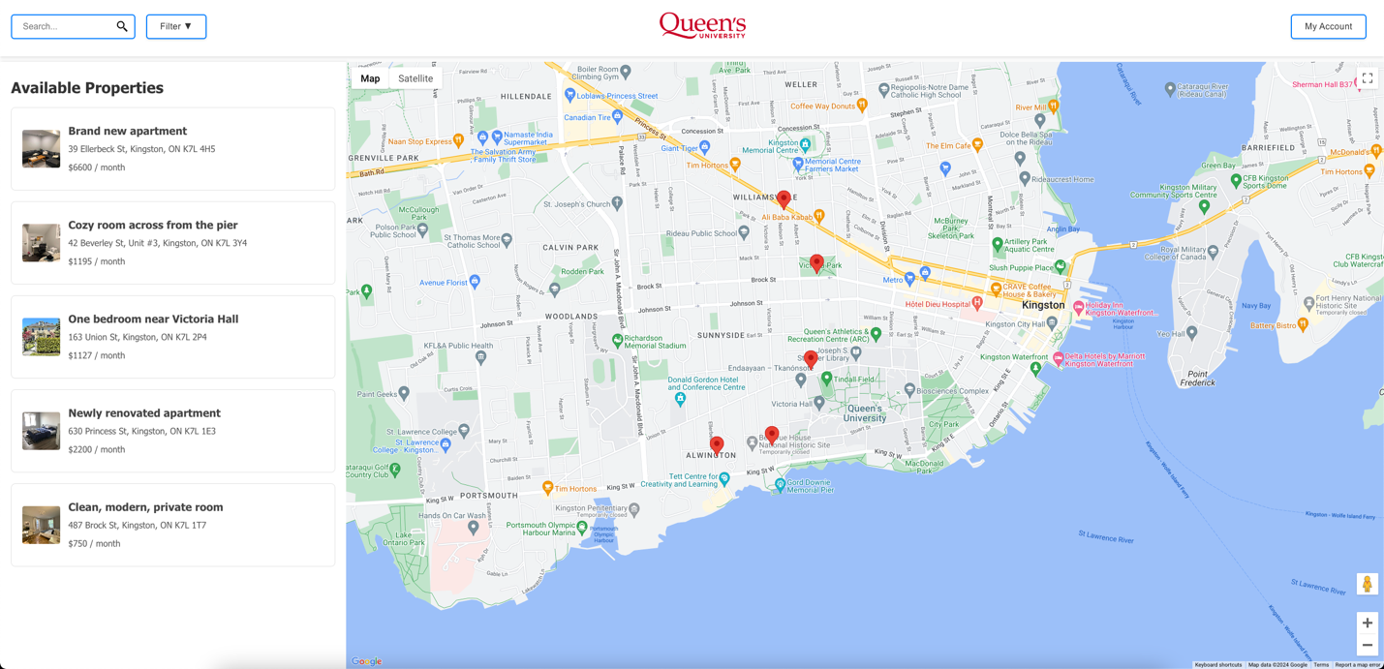

The *left sidebar* allows users to browse through available properties quickly. This section dynamically populates with the property listings in the database, which are queried upon page initialization:

/ Function to populate the sidebar with property modules

function populateSidebarWithPropertyModules(propertiesData) {

isMainMapViewActive = true;

const sidebar = document.getElementById('sidebar');

sidebar.innerHTML = '';

toggleNavButtons(false);

document.getElementById('map').style.display = 'block';

document.getElementById('property-images').style.display = 'none';

sidebar.innerHTML = '<h2>Available Properties</h2>';

if (Array.isArray(propertiesData) && propertiesData.length > 0) {

propertiesData.forEach((property) => {

const propertyModule = document.createElement('div');

propertyModule.className = 'property-module';

propertyModule.innerHTML = `

<div class="property-info">

<h3>${property.listing_name}</h3>

<p>${property.address}</p>

<p>$${property.monthly_rent} / month</p>

</div>

<img src="${property.pictures.length > 0 ? property.pictures[0] : ''}" alt="Property image" class="property-listing-img">

`;

propertyModule.addEventListener('click', () => displayPropertyDetails(property));

sidebar.appendChild(propertyModule);

});

} else {

sidebar.innerHTML += '<p>No properties available.</p>';

}

if (propertyDetailMap) {

propertyDetailMap = null;

const propertyMapContainer = document.getElementById('property-location-map');

if (propertyMapContainer) propertyMapContainer.style.display = 'none';

}

}

Each item in the *left sidebar* contains only the most important details about the property: the address, the monthly rent cost, and the first image. Clicking a property element will take you to its *property page*, which contains a more detailed view of the listing.

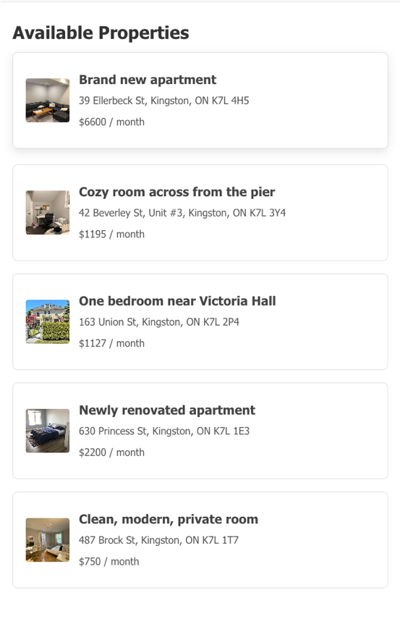

The *top navigation bar* includes an advanced search bar. This search bar features autocomplete functionality, using the Google Places API to suggest addresses and locations such as landmarks, campus buildings, and restaurants, as users type.

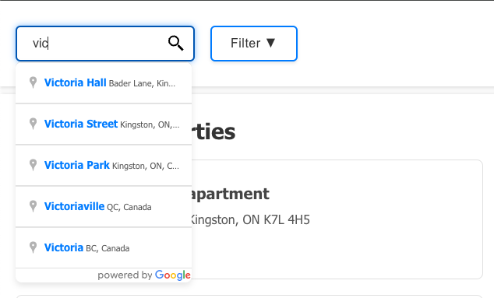

To improve the accuracy of search results, we set a bias towards locations within Queen’s campus, as well as Canadian addresses in general:

// Function to initialize autocomplete functionality for the search input

function initAutocomplete() {

const input = document.getElementById('search-input');

const options = {

componentRestrictions: { country: 'CA' },

bounds: new google.maps.LatLngBounds(

new google.maps.LatLng(44.180, -76.530), // Southwest corner of Kingston

new google.maps.LatLng(44.250, -76.450) // Northeast corner of Kingston

)

};

The Google Places API cannot directly receive an address as input. Its parameters are *(latitude, longitude)*, so we must use a middleman: the Google Geocoding API. Once a search is executed, the Google Geocoding API is used to convert the address into geographical coordinates that can then be passed to the Google Places API:

// Function to geocode an address and return its latitude and longitude

async function geocodeAddress(address) {

const geocoder = new google.maps.Geocoder();

return new Promise((resolve, reject) => {

geocoder.geocode({ 'address': address }, (results, status) => {

if (status === 'OK') {

const location = results[0].geometry.location;

resolve({ lat: location.lat(), lng: location.lng() });

} else {

reject('Geocode was not successful for the following reason: ' + status);

}

});

});

}

These coordinates are then used to center the map on the searched location, where a distinct circular marker is created. On hover, the marker displays the address of the search query, providing immediate visual confirmation and context.

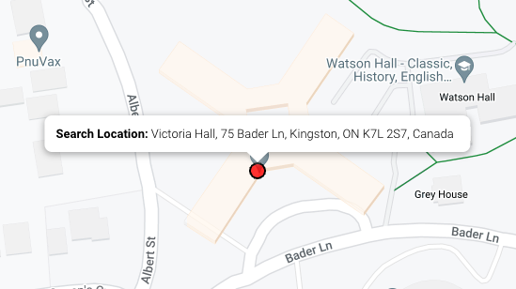

The *map* component calls the Google Static Maps API. This is key feature of our application that takes up most of the homepage and provides an interactive canvas where users can visually explore properties. It includes the standard roadmap view, and a satellite view for a bird's-eye perspective of areas. The built-in functionality of this API also includes a terrain view that highlights physical features like mountains, but we purposefully disabled this feature as we felt it wasn’t relevant for our purposes - Kingston only has one terrain type.

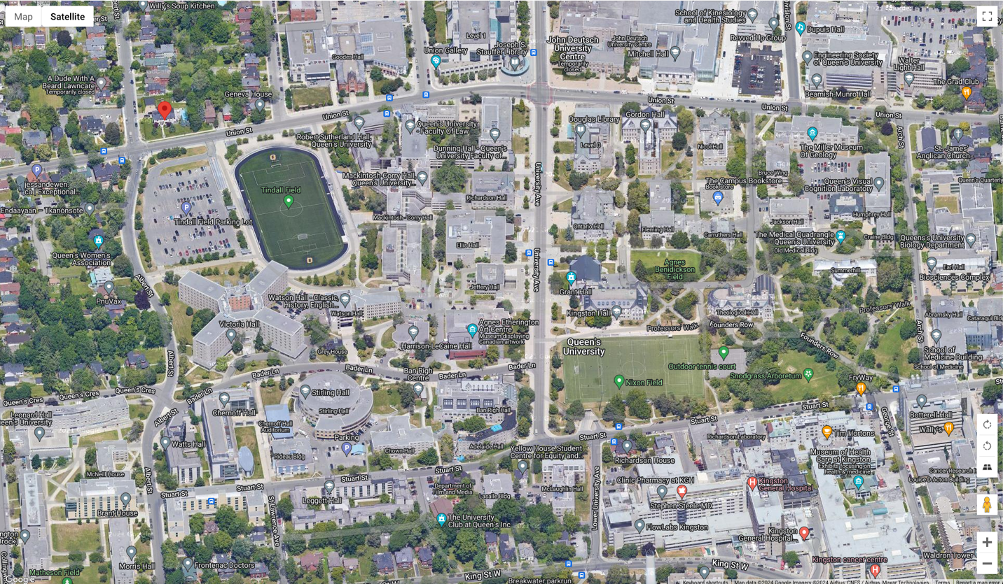

The API also allows for Street View functionality. By dragging the Street View icon to a spot on the map, users can get a ground-level view of the area, offering a realistic feel of the surroundings. This will help users better assess the suitability of a property’s location in relation to their personal needs.

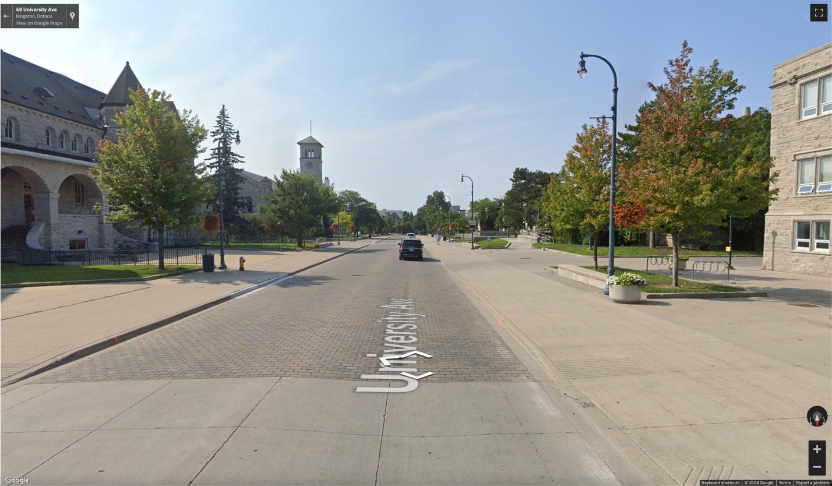

To visually represent properties, upon initialization, the map dynamically populates with red markers, each representing the location of an available property, similar to how the property listings are populated in the *left sidebar*. Hovering over a marker reveals an info bubble with key information about the property, such as the name, price, and a brief description. This allows users to quickly assess properties of interest without leaving the map view.

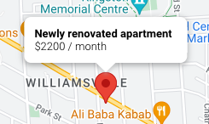

Clicking on a property marker will take you to its page, in the same fashion clicking on a property listing in the left sidebar does.

The other markers on the map are created by the Google Static Maps API. For example, grey markers represent school buildings, blue markers represent stores, and green markers represent parks.

**Property Page**

Once the user clicks on a property, either by clicking on its listing in the *left sidebar* or its marker on the *main map*, they will be taken to a comprehensive view of that listing. This page again, is made of three components: the *left sidebar*, the *top navigation bar*, and the *picture viewer*. The sizing, spacing, and overall style of these elements is consistent with the other pages. We used JavaScript async functions here to greatly improve load times.

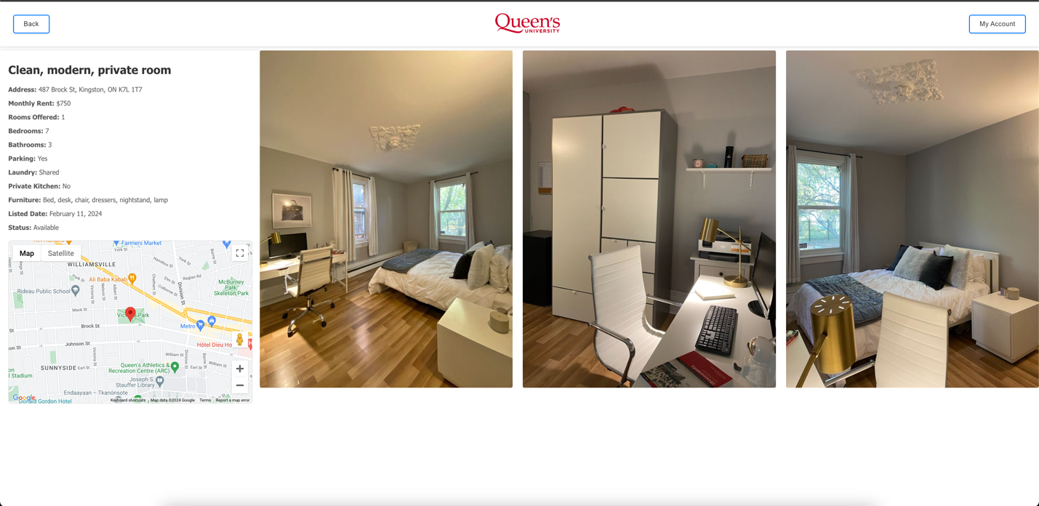

The left sidebar is now used to display all information about the property, such as the number of bedrooms and bathrooms, parking availability, and more:

// Function to display property details in the sidebar and on the map

async function displayPropertyDetails(property) {

// …

const sidebar = document.getElementById('sidebar');

sidebar.innerHTML = `

<h2>${property.listing_name}</h2>

<p><strong>Address:</strong> ${property.address}</p>

${property.house_type === 'Apartment' && property.floor_number !== null ? `<p><strong>Floor Number:</strong> ${property.floor_number}</p>` : ''}

<p><strong>Monthly Rent:</strong> $${property.monthly_rent}</p>

${property.number_of_offered_rooms ? `<p><strong>Rooms Offered:</strong> ${property.number_of_offered_rooms}</p>` : ''}

<p><strong>Bedrooms:</strong> ${property.bedrooms}</p>

<p><strong>Bathrooms:</strong> ${property.bathrooms % 1 === 0 ? Math.floor(property.bathrooms) : property.bathrooms}</p>

<p><strong>Parking:</strong> ${property.parking ? 'Yes' : 'No'}</p>

<p><strong>Laundry:</strong> ${property.laundry}</p>

${property.house_type === 'House' && property.fenced_yard !== null ? `<p><strong>Fenced Yard:</strong> ${property.fenced_yard ? 'Yes' : 'No'}</p>` : ''}

${property.house_type === 'House' && property.detached_or_semi ? `<p><strong>Type:</strong> ${property.detached_or_semi}</p>` : ''}

${property.house_type === 'Apartment' && property.elevator !== null ? `<p><strong>Elevator:</strong> ${property.elevator ? 'Yes' : 'No'}</p>` : ''}

${property.private_kitchen !== null ? `<p><strong>Private Kitchen:</strong> ${property.private_kitchen ? 'Yes' : 'No'}</p>` : ''}

<p><strong>Furniture:</strong> ${property.furniture}</p>

<p><strong>Listed Date:</strong> ${new Date(property.date_listed).toLocaleDateString('en-US', { year: 'numeric', month: 'long', day: 'numeric' })}</p>

<p><strong>Status:</strong> ${property.status}</p>

`;

// …

Below this information, is a mini map, zoomed in and centered at the property. This gives the user quick location context for the property without having to go back to the main map. It’s fully functional just like the main map and can be expanded to fill the full screen.

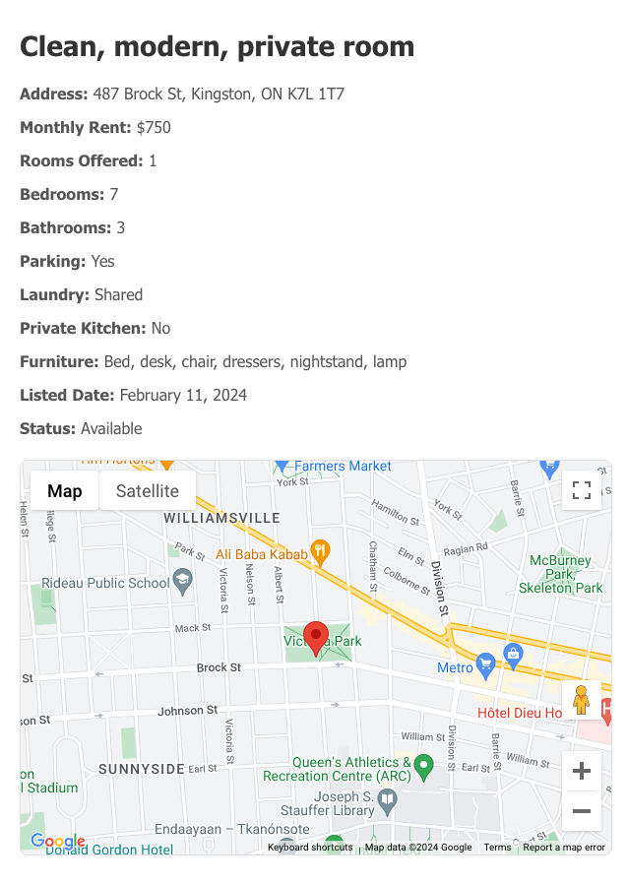

The *top navigation bar* remains mostly the same as it is in the homepage, except the search bar is now replaced with a back button. The Queen’s Logo can also be clicked on to go to the homepage.



On the right-hand side of the property view page, replacing the main map from the homepage, is the *picture viewer*.   
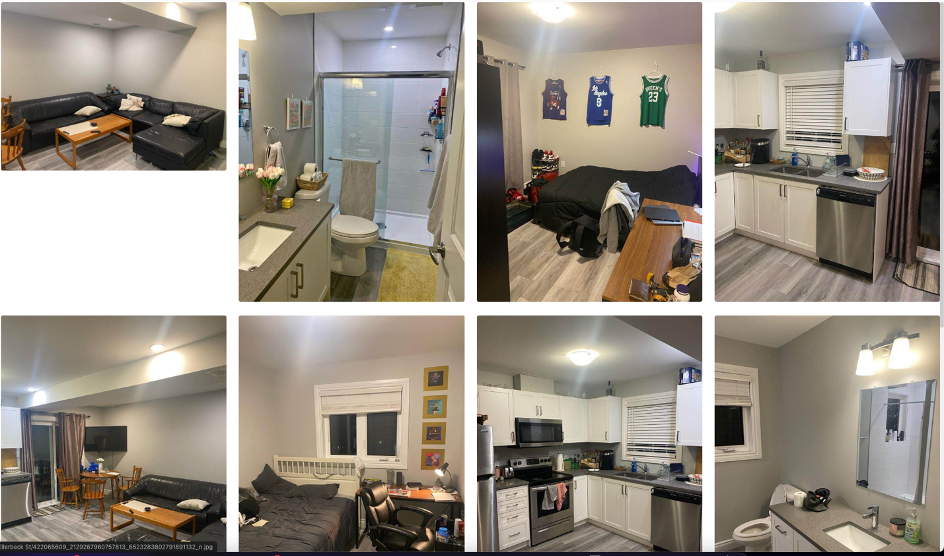The property’s associated images are fetched from the database and are displayed here, in a grid layout. The size of the images will dynamically adjust based on how many there are. If a property has fewer than four images, they will enlarge to make use of the available white space:

.picture-viewer-container {

position: absolute;

top: 120px;

right: 0;

bottom: 0;

left: 25%;

overflow-y: auto;

/* Enable scrolling for overflow content */

display: grid;

grid-template-columns: repeat(auto-fill, minmax(200px, 1fr));

grid-gap: 10px;

padding: 10px;

box-sizing: border-box;

}

Clicking into any image will open a *lightbox gallery* overlay.

**Lightbox**

An important part of picture navigation is our *lightbox gallery*. It's initialized using a simple JavaScript call that activates the lightbox for any image link tagged with data-fancybox="gallery".

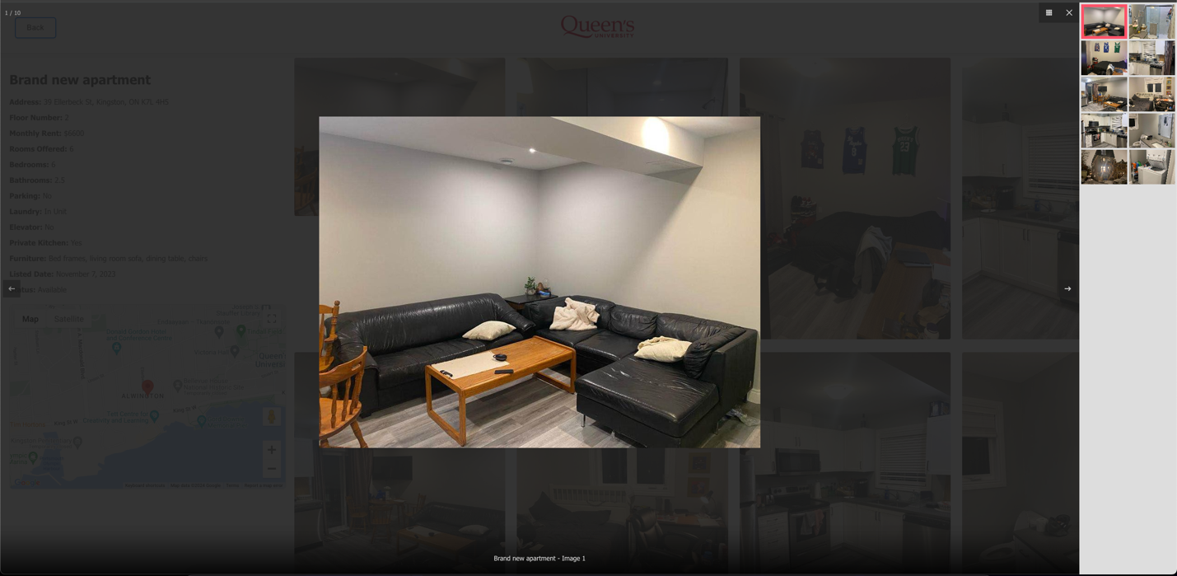Using the JavaScript Fancybox library, we created a responsive and immersive gallery that allows users to browse through the full-resolution property images in a lightbox overlay, supporting gestures like swiping and keyboard shortcuts for easy navigation:

// Function to initialize the Fancybox plugin for image galleries

function initializeFancybox() {

$('[data-fancybox="gallery"]').fancybox({

buttons: ['thumbs', 'close'],

thumbs: {

autoStart: true,

fitToView: true,

},

loop: false,

infobar: true,

keyboard: true,

wheel: "auto",

afterShow: function (instance, current) {

// Intentionally left blank to prevent history state manipulation by Fancybox

}

});

}

The lightbox keeps track of the images in an array and will stop the user from navigating to the previous image if the current image being viewed is the at the [0] index, and vice versa if the current image is at the [-1] index. The navigation arrow will also be greyed out as a visual indicator that the user is at the first or last image.

**Backend**

**Node.js and Express Setup**

For the backend of our project, we used Node.js with the Express framework. Since this platform is a full-stack application, we must use JavaScript for the frontend, so we kept it simple. The Express server listens on a designated port, 3000, ready to handle incoming requests. Factoring in Node.js's non-blocking I/O model, this decision both sped up our development process and allowed for high-performance, in our usage.

We implemented essential middleware like CORS to handle cross-origin requests to ensure our API could be securely accessed from different origins, specifically our frontend application hosted on each of our separate local machines.

The backend interacts with our MySQL database through the mysql2 library. We established a connection pool in database.js to improve performance and reliability when handling concurrent database queries:

// Create a connection pool and export it

const pool = mysql.createPool({

host: 'localhost',

user: 'root',

password: 'housingmatch',

database: 'cisc_499',

waitForConnections: true,

connectionLimit: 10,

queueLimit: 0

});

**API Endpoints**

We made two primary endpoints:

// Endpoint to fetch all properties

app.get('/api/properties', async (req, res) => {

try {

const [results] = await db.query('SELECT * FROM property');

res.json(results);

} catch (error) {

console.error('Error fetching properties:', error);

res.status(500).json({ error: error.message });

}

});

// Endpoint to fetch pictures for a specific property

app.get('/api/pictures/:pid', async (req, res) => {

const pid = req.params.pid; // Extract PID from URL

try {

const [results] = await db.query('SELECT * FROM pictures WHERE PID = ?', [pid]);

res.json(results);

} catch (error) {

console.error('Error fetching pictures:', error);

res.status(500).json({ error: error.message });

}

});

1. */api/properties*: Fetches all property listings from the database. This is necessary for us to populate the left sidebar with properties and the main map with markers, upon starting the application.
2. */api/pictures/:pid*: Retrieves all images associated with a specific property, identified by its PID. This enables us to dynamically load images on the property detail pages.

**Error Handling and Performance**

We added try-catch blocks and error handling mechanisms to every necessary function to provide meaningful feedback during API interactions. For example, upon encountering database retrieval issues, the API responds with an appropriate message. In this example, I tried to start the application with my database turned off:

